PROGRAM
import cv2
import numpy as np

img = cv2.imread("rotation_image.png")

if img is None:
print("Image not found! Check the image name.")
else:
rows, cols = img.shape[:2]

pts1 = np.float32([
[50, 50],
[200, 50],
[50, 200]
])

pts2 = np.float32([
[10, 100],
[200, 50],
[100, 250]
])

matrix = cv2.getAffineTransform(pts1, pts2)

transformed = cv2.warpAffine(
img, matrix, (cols, rows)
)

cv2.imshow("Original Image", img)
cv2.imshow("Affine Transformed Image", transformed)

cv2.imwrite("affine_transformed.png", transformed)

cv2.waitKey(0)
cv2.destroyAllWindows()

print("Affine transformation completed successfully!")

OUTPUT
The original image and the affine-transformed image are displayed. The transformed image shows changes in the positions of points, resulting in a shifted or slanted appearance. The output is saved as affine_transformed.png.
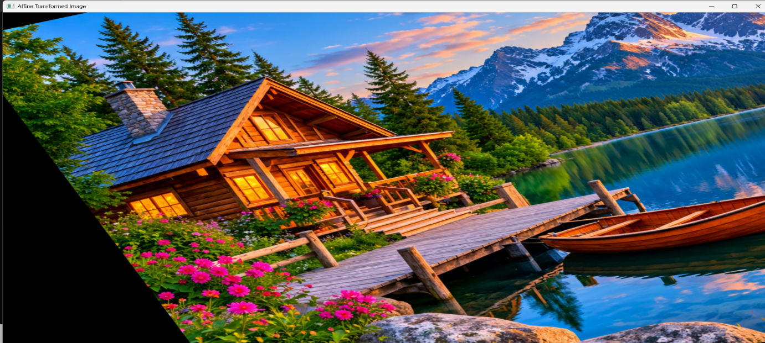


RESULT
Thus, affine transformation was successfully performed on the given image using Python and OpenCV.

